Purpose: The PA DCNR, Butler County Parks & Recreation, Penn Township, and HRG representatives met at 11:00 a.m. on November 13, 2023, in the Penn Township Municipal Building, 157 East Airport Road, Butler, PA 16002 for the Harcrest Park Phase II design and engineering update and a tour of the park.

Attending:
- Bert Mowry - Penn Township Supervisor
- Bill Geibel - Park neighbor
- David Bruni - Township resident
- Doug Roth - Penn Township Supervisor & Park Committee
- James Feath - HRG - Registered Landscape Architect

Distribution of minutes:
- Attending
- Adriene Smochek - PA Bureau of Recreation & Conservation
- Ashley Helmstaedter - Butler County Parks & Recreation
- Cathy Woller - Park neighbor
- Christina Sarson - HRG Land Planner
- Clinton Bonetti - Penn Township Land Use Administrator
- Craig Thomasmeyer - Park neighbor
- Dan Wible - Penn Township PWD Foreman
- Dave Andrews - Connoquenessing Water Shed Alliance
- Diane Curry - Park neighbor
- Janet Sperling - Park neighbor
- Jim Woller - Park neighbor

- Karen Trempus - Park Committee
- Lance Welliver - Butler County Director of Parks & Recreation
- Melissa Heagy - Park Committee
- Sam Ward - Penn Township Supervisor
- Theodosia Regal - Park neighbor & Park Committee

  - John Weston - BSA Troop 53 Scoutmaster
  - Kelly Weston - BSA Troop 53 Secretary
  - Kimberly Geyer - Butler County Commissioner
  - Linda Zerfoss - Penn Township Manager
  - Mark Gordon - Butler County Chief of Economic Planning
  - Mark Hansford - PA DCNR
  - Michael Corle - Penn Township SEO
  - Sarah Giamporcaro - Park neighbor
  - Scott Gumto - Park Committee
  - Tammy Able - Penn Township Consultant
  - Will Pitts - Butler Eagle

Discussion:
- Melissa Heagy made the motion and Karen Trempus seconded the motion to approve the minutes of the meeting held on July 13, 2023. The motion was approved.
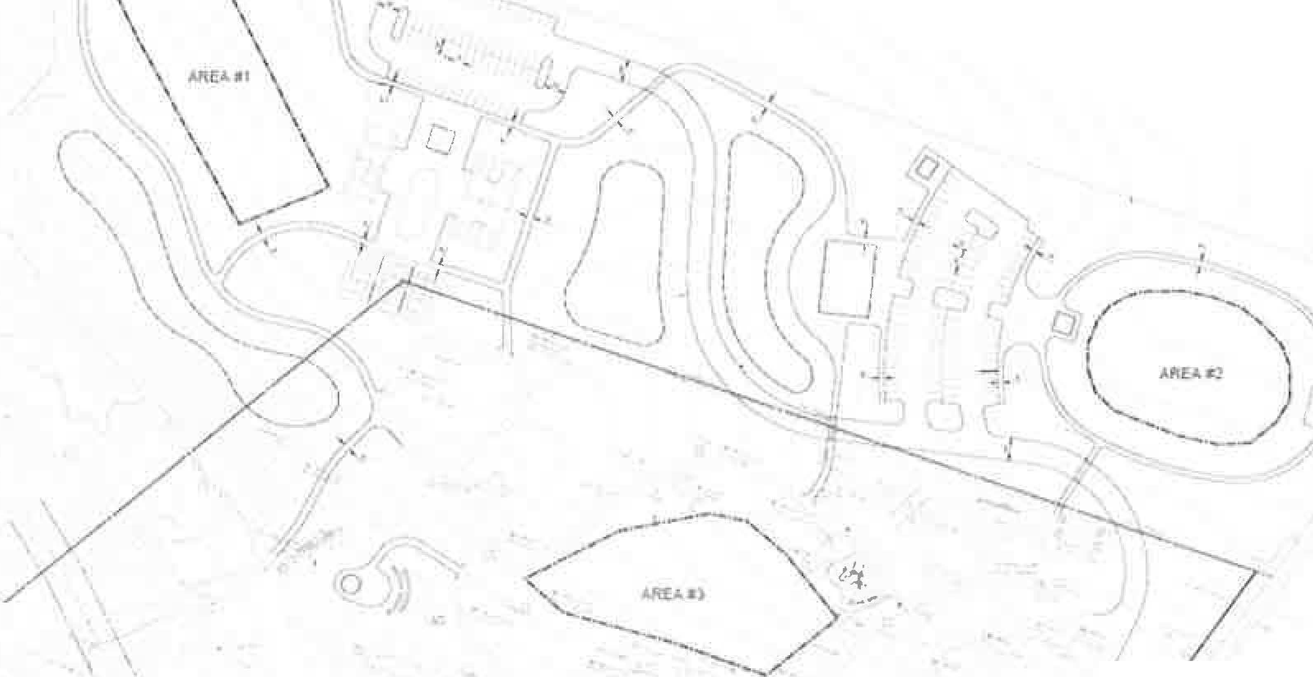
- Sam Ward, Penn Township Sewage Enforcement Officer (SEO}, Mike Corle, and Public Works Department (PTPWD) representatives Dan Wible and Bob Renfrew met at the site on August 21, 2023, to discuss on-site testing to determine if on-lot sewage is a viable option for Phase I and II. A water well will also be added to the scope of work. HRG provided prospective locations as shown below. Sam Ward will do a narrative for the necessary on-lot sewage permits. Refer to the minutes of the August 21, 2023 meeting.
cHRG
f
"
Ult
.&..IT..l!.I.AYOU'
;

iI
#
T⁾.
,
I
'(\,'

https://penntwpbuller-my sharepoint,com/personal/lzerfoss_penntownship_org/documents/hercrest park committee mealing 11-13-2023,docm

- Sam Ward advised the Penn Township Public Works Department (PTPWD) representative, Dan Wible, suggested that the row of Arborvitae trees along the Phase I Northern border be removed because of their poor condition. The PTPWD has been removing dead Arborvitae trees. Consider trimming these remaining Arborvitae trees to be more uniform and/or moving them.
- Theodosia Regal discussed starting a pollinator garden in an area along Three Degree Road and starting to plant pollinator plants before Winter. Theodosia Regal will provide the pollinator plants that she has been growing. Melissa Heagy made the motion and Karen Trempus seconded the motion to approve placing the pollinator garden between the Maple and Pine trees along Three Degree Road. The motion was approved.
- Theodosia Regal discussed the trees that are available through a "Million Trees" program. Doug Roth picked up about 100 tree seedlings. They are Willow, Silky Dogwood, Hawthorn, Bass Wood, and Alder. Jim Feath stated that these species should be planted in wet areas such as the small stream running through the park. Doug Roth gave the Connoquenessing Water Shed Alliance representative, Dave Andrews all the Willow tree seedlings to plant along Thom Creek. There are approximately 50 remaining tree seedlings that need to be planted. Doug Roth will schedule a date to plant these tree seedlings. Volunteers are needed.
- Theodosia Regal also has a Tulip tree that she will donate to be planted along the park stream.
- Doug Roth asked HRG to recommend park secondary succession areas. The Park Committee will review and approve these areas at the next meeting.
- Doug Roth stated that Township resident, Bob Winters, will donate building the barn stone sign along Brownsdale Road in front of the Storage Building. The barn stone was salvaged from the Hartzel barn when it was removed. The sign will have the Harcrest Park name on two sides with the address number facing Brownsdale Road.
- Sam Ward reported that a theft occurred at the park on September 30, 2023. A family was setting up for a party, left the park for a short period of time, and returned to find that some of the Items that were set up had been stolen. The incident was reported to the Penn Township Police. The Park Committee will consider installing security cameras in the next phase.
- Sam Ward reviewed the DCNR Recreation and Conservation Advisor representative, Adriene Smochek's email, dated September 27, 2023, which provides a registration link to the DCNR Workshop, a copy of her PSATS workshop presentation, and offers to set up a site visit with the DCNR Chief, Mark Hansford at Harcrest Park. Doug Roth will contact DCNR, HRG, and Butler County Parks and Recreation representatives to set up the site visit before late November 2023.
- The Virtual Workshop for the DCNR Grant Program preregistration is available at events@dcnr.pa.gov. Select November 16 using the calendar and then click "Register'' in the box for the grant workshop.
- Penn Glade Lions representative, David Bruni, suggested that a bicycle repair station with compressed air be added in the park near the bike rack. Dave Bruni provided a photo of the proposed bicycle repair station. There are many bicycle riders who frequently stop at the park to use the restrooms. The Penn Glade Lions will donate the repair station, at a cost of approximately $2,000, and the Penn Township PWD will provide the concrete pad. Melissa Heagy made the motion and Karen Trempus seconded the motion to allow the installation of the bicycle repair station near the bike rack. The motion was approved.
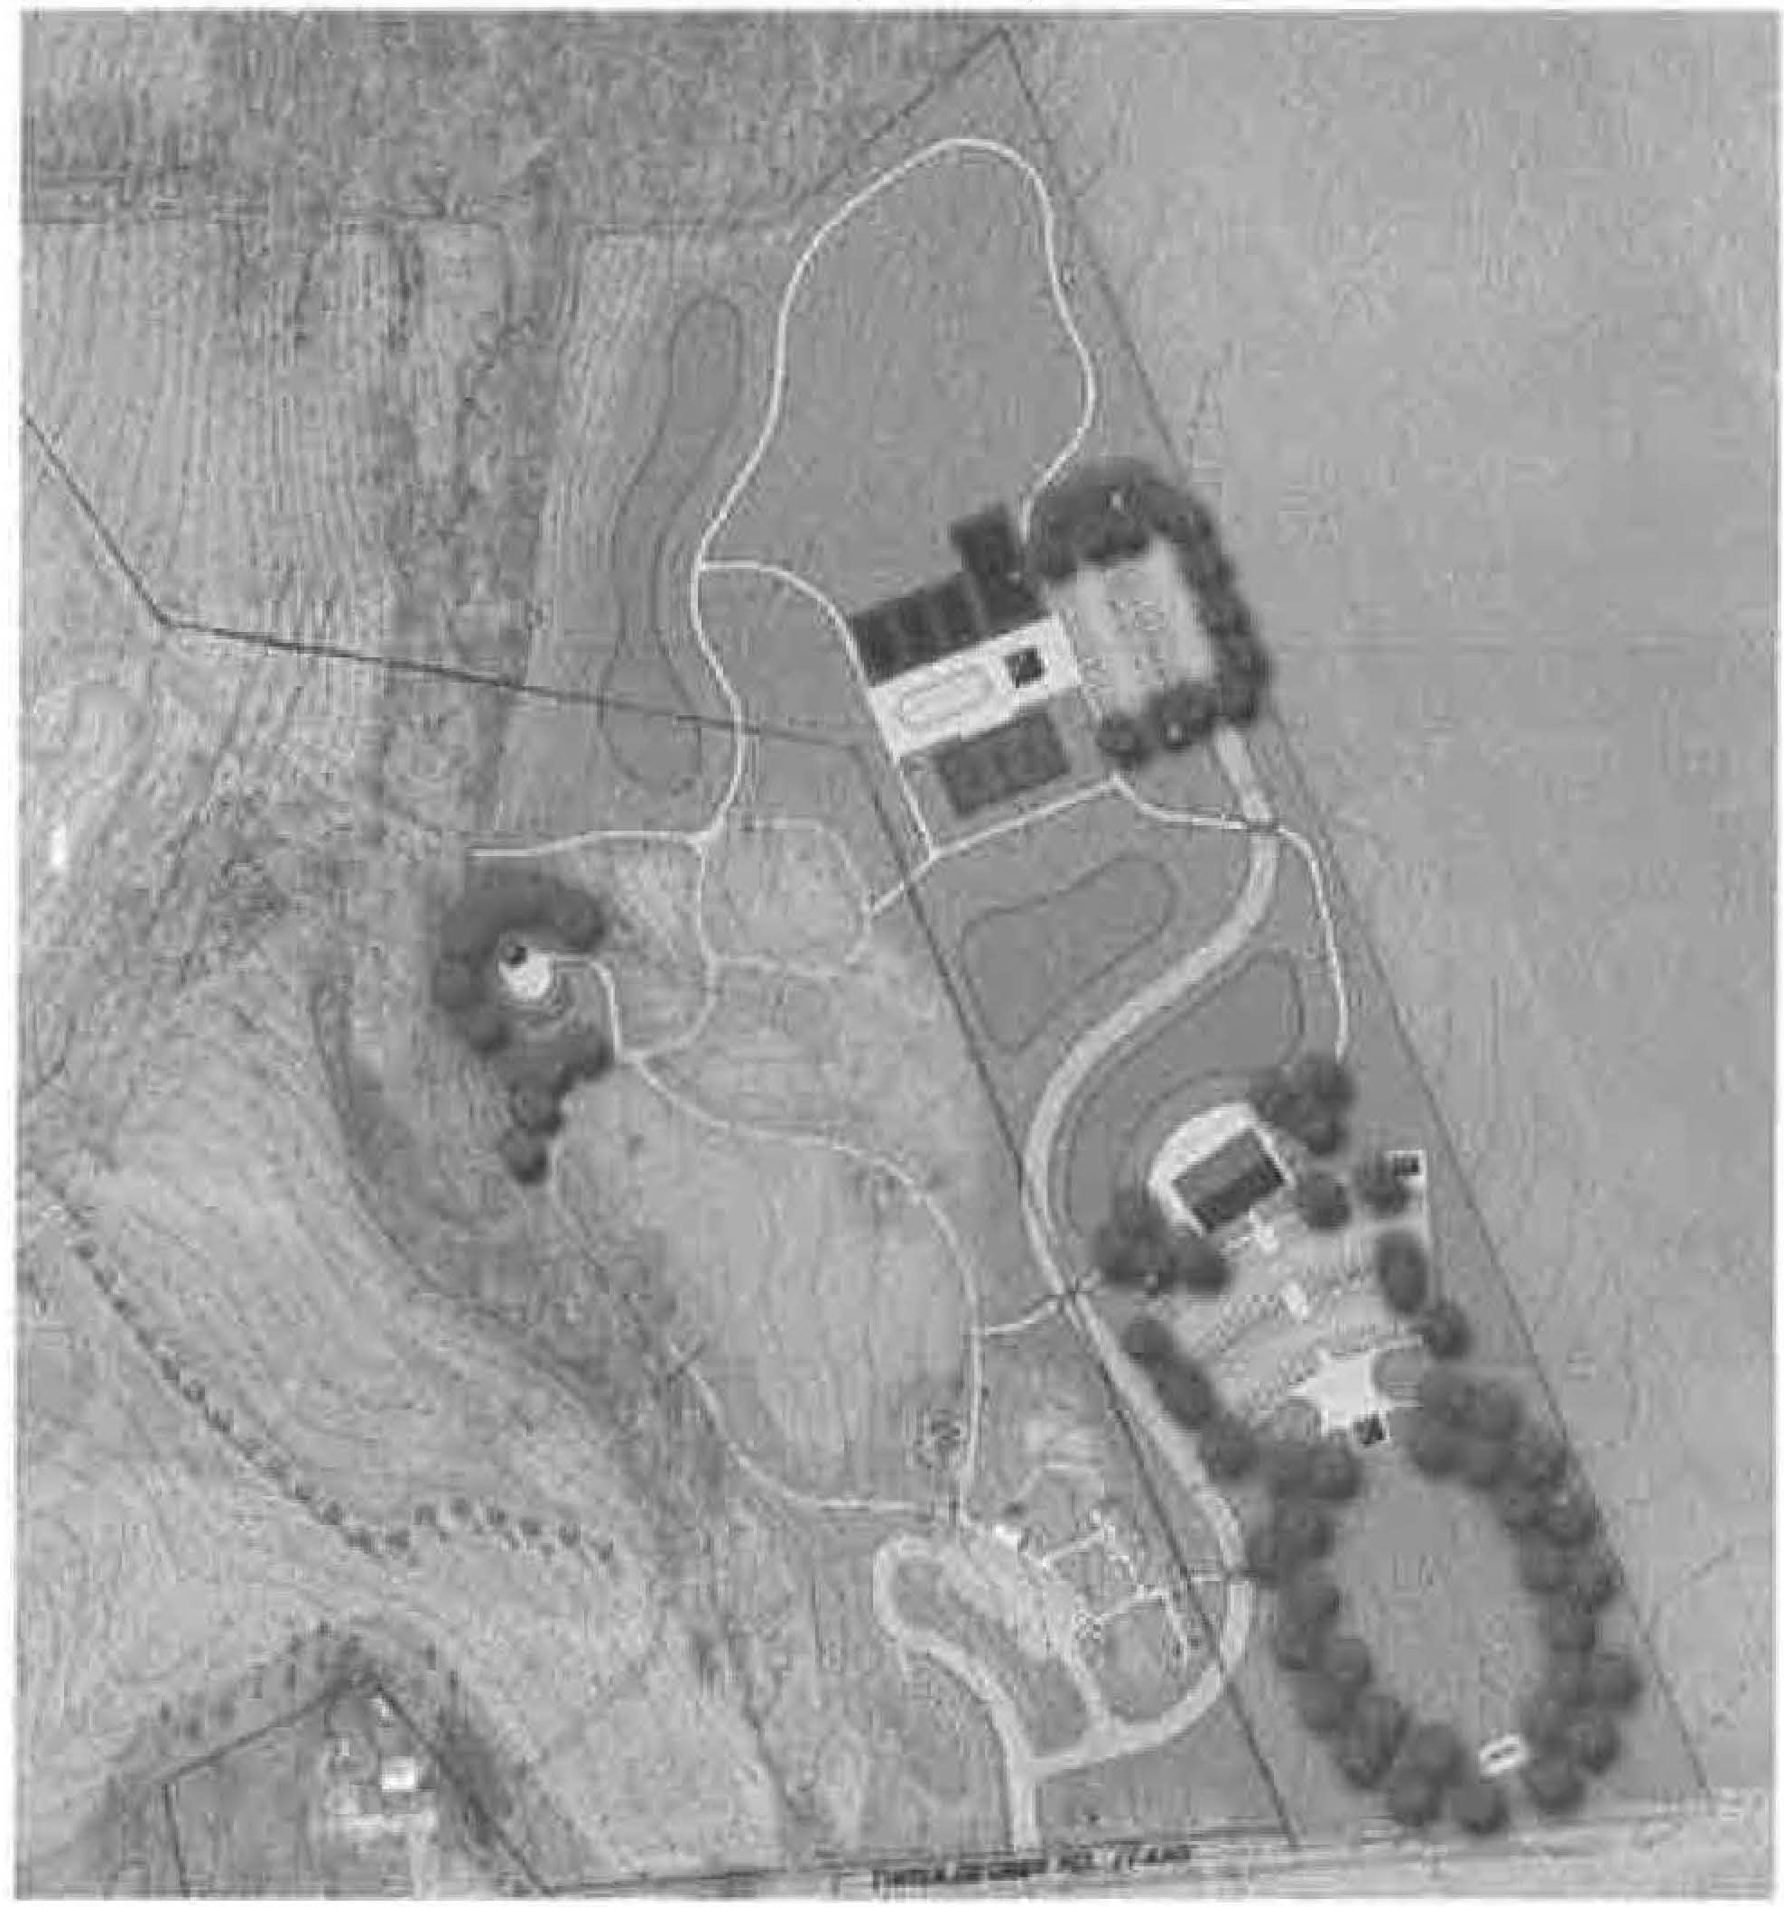
- Jim Feath stated that HRG has continued working on the Phase II permit and design documents and reviewed the HRG PowerPoint presentation, dated October 18, 2023, as follows:

Where we are
  - Surwy
  - w t11nd dtHneation
  - P imin•ry ,-jte grading
  - "'°liminuy stormwM: r

r

I
I
\\
- I I I - I-
- The site survey and wetland delineation are complete. Design work continues for the site grading and stormwater management.

2
https://penntwpbutler-my.sharepolnt.com/personaUlzerfosspenntownehip_org/documents/harcreet par1< committee meeting 11-13-2023.docm

Project Schedule

·-­

•

...v...........
f,n..a.ltl•
I
, ,
0-.,til.JH -'i.
I

i:."..".".-"..'....

..,_,,,

--
-
.l ' <

Design and Engineering NPDES/E&S Submittal DCNR Submittal
n •-
r.o11 ,,,. '.
Project Schedule/Milestones
Anticipate NPDES approval
General sitework - Township stafl TWP BOS authorize Bid
Project to bid
Project awarded Approval to proceed Work completed Final Site Inspection Closeout
•
September-January January 2024
January 2024
March 2024
March 2024
May 2024
July 2024
July-September 2024
October 2024
Spring 2025 Summer2025 Fall 2025

- HRG will begin soil testing to detennine the stormwater infiltration rate. The Penn Township PWD will provide a backhoe and a water Buffalo.
- Jim Feath advised that Penn Township will need to provide payments and sign applications for the various pennits in December 2023.
- HRG will continue preparing pennit and design documents.
- HRG will develop documents requesting an additional 25% of the current grant amount for Phase II facilities and a 2024 grant application to continue additional work shown on the updated Master Plan. Refer to the drawing shown above.
- Sam Ward asked how the new tree seedling plants will be identified. The Committee will consider providing identification labels with a waterproof marking pen.
- The next Park Committee meeting will be held in the Penn Township Municipal Building, 157 East Airport Road, Butler, PA 16002, on January 24, 2023, at 6:30 p.m.
- Melissa Heagy made the motion and Karen Trempus seconded the motion to adjourn. The motion was approved and the meeting concluded at 7:45 p.m.
- Minutes of the meeting will be posted on the Penn Township website, www.penntownship.org under Documents, Park Committee.
- Post-meeting note: Theodosia Regal and Doug Roth planted 57 tree seedlings on October 22, 2023. They found several Alder trees growing along the stream bed.

Respectfully submitted,
( 'j{UWL µL(J(}l,t{
Samuel M. Ward, Supervisor

3
htlpsJ/penntwpbutler-my.sharepolnt.com/personal/lzerfoss_penntownshlp_org/documents/harcrest parl< committee meeting 11-13-2023.docm

