Purpose: Penn Township and HRG representatives met at 10:30 a.m. on January 10, 2024, in the Penn Township Municipal Building, 157 East Airport Road, Butler, PA 16002 for the Harcrest Park Phase II site grading and stormwater.

Attending:
- Bert Mowry - Penn Township Supervisor
- Devin Dunwoody, HRG- Project Manager
Distribution of minutes:
- Attending
- Adriene Smochek - PA Bureau of Recreation & Conservation
- Ashley Helmstaedter - Butler County Parks & Recreation
- Bill Geibel - Park neighbor
- Cathy Woller - Park neighbor
- Christina Sarson - HRG Land Planner
- Clinton Bonetti - Penn Township Land Use Administrator
- Craig Thomasmeyer - Park neighbor
- Dan Wible - Penn Township PWD Foreman
- Dave Andrews - Connoquenessing Water Shed Alliance
- Diane Curry - Park neighbor
- James Feath - HRG - Registered Landscape Architect
- Janet Sperling - Park neighbor
- Jim Woller - Park neighbor

- Doug Roth - Penn Township Supervisor & Park Committee
- Sam Ward - Penn Township Supervisor

  - Karen Trempus - Park Committee
  - Kimberly Geyer - Butler County Commissioner
  - Lance Welliver - Butler County Director of Parks & Recreation
  - Linda Zerfoss - Penn Township Manager
  - Mark Gordon - Butler County Chief of Economic Planning
  - Mark Hansford - PA DCNR
  - Melissa Heagy - Park Committee
  - Michael Corle - Penn Township SEO
  - Sarah Giamporcaro - Park neighbor
  - Scott Gumto - Park Committee
  - Steve Harmon - HRG, EIT
  - Tammy Able - Penn Township Consultant
  - Theodosia Regal - Park neighbor & Park Committee
  - Will Pitts - Butler Eagle

Discussion:
- HRG representative, Devin Dunwoody, has been assigned to this project as Project Manager.
- Devin Dunwoody reviewed the Harcrest Park Phase 2 Site Grading plans shown below.
" '-
West

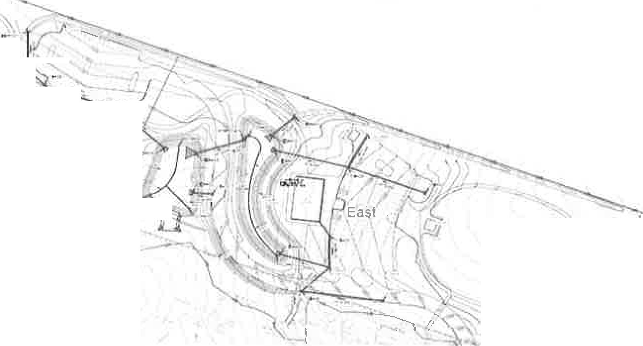
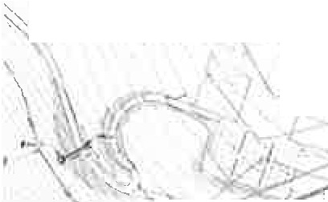
'
'
-,-
' ◊-- : '•.·
' t
J
•
-
II
'
/
1.-P·
1.fl
;--
' '
I
' f:
I

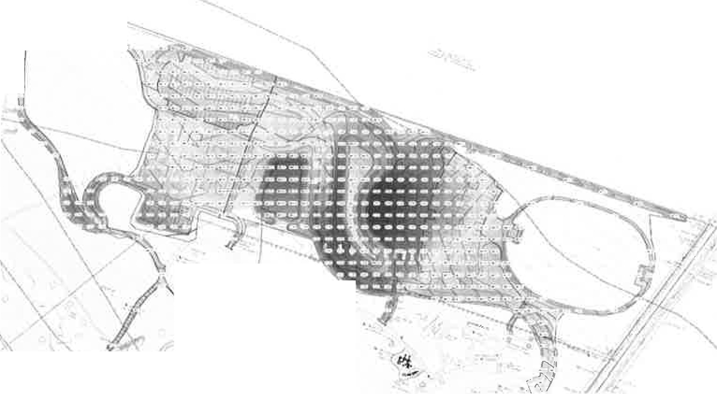
'
I
"-;.:
•
I
•
t)
J
(
\ I --' I • \
- The cut is shown in red and the fill is shown in blue.

https:1/penntwpbutler-my sharepoint com/personal/lzerfosspenntownship_org/documentslharcrest park site grading and stormwater meeting 1-10-2024,docm

- Sam Ward added the red line separating the East and West areas as a suggested construction phasing. The Eastern portion would be completed in the current phase as the current project has limited funding. The Western portion would be completed when funding is available.
- Sam Ward stated that HRG representative, Jim Feath, previously pointed out that the Penn Township Public Works Department (PWD) would have to complete a substantial amount of the bulk grading and stomiwater detention, piping, and catch basin structures early in the phases of construction.
- Penn Township agrees that both stormwater detention basins and the associated stormwater piping must be completed in the first phase. Perhaps the stormwater piping for the Western area of development could be "stubbed out" from the lower detention basin and completed with the later phase.
- Penn Township must consider the bulk earth quantities for both phases. HRG provided approximate cut and fill earth quantities for both the East and West areas shown on the attached, marked-up drawing. A red line is drawn between these areas to delineate the phases. Devin Dunwoody confirmed that the cut and fill earth quantities balance. There are approximately 7,000 cubic yards of cut and fill in the Eastern area and approximately 1,500 cubic yards in the Western area. These quantities do not include stripped topsoil. Suitable fill will be placed under structures, concrete paving, and bituminous paving at roads and parking areas. Doug Roth anticipates that the soil material will be sandy shale.
- HRG will provide a copy of the stormwater infiltration testing which was completed recently.
- HRG will provide approximate quantities of the stormwater piping in each area.
- Penn Township will retain the HRG survey crew, as an additional service, to provide lines and grades.
- Penn Township will retain an independent testing laboratory for concrete and soil compaction testing and inspection.
- Excess quantities of topsoil stripped from the developed areas of paving and structures will be spread over future lawn areas.
- Earth and topsoil quantities will help Penn Township develop a sequence of work and budget.
- Penn Township PWD manpower requirements? To be determined.
- Penn Township PWD equipment requirements:
- Township-owned grader, trucks, backhoe, and loader.
- Potential rental equipment includes a small dozer and vibratory roller.
- Project Schedule:

Design and Enginee,ing NPDES/E&SSubmlltat DGNR Subm11tal
Anticipa1e NPDES approval
Gerteral sileWOlk. Township Sia!! TWP BOS authorize Sid
ProJecl l0 bid Project awarded Approve! 10 proceed Work compteled Final Sile Inspection
- Clo,eout
September - Janu1;1ry January2024 January 2024
March2024
March2024
May 2024
July2024
Juty-Septeml>er 2024
Oclober 2024 Spring2025 Summer 2025 Fall2025

- HRG will provide the test results of the stomiwater infiltration rate which was completed recently.
- Doug Roth stated that the PWD would use the established construction entrance at the Northeast property corner for the equipment and trucks during construction.
- HRG will prepare an Erosion and Sedimentation Control plan.
- Penn Township will install sleeves for future utilities under paved and concrete areas.
- Penn Township is evaluating both on-lot wastewater treatment and a grinder pump system from the park to the SAA sanitary sewer system located on Penn Drive approximately one quarter mile North.
- DCNR advised that Penn Township can apply for an additional 25% ($75,000) on our existing $300,000 grant. HRG is to prepare the necessary documents to apply for this additional funding in early 2024.
- Penn Township intends to submit another grant application in early 2026 after the current grant work is complete. These additional funds will be necessary to get this phase and the subsequent Master Plan phases completed.
- Doug Roth stated that there are approximately 2,000 tons of asphalt millings stored at the PWD yard which will be used as the road and parking area paving base course.
- Doug Roth suggested that we should consider using porous paving, such as GeoPave Porous Pavement System with aggregate/topsoil engineered infill, for some overflow parking areas to reduce the asphalt paving and stormwater runoff. HRG is to consider this alternative paving and make recommendations.
- The motion was approved and the meeting concluded at 11:45 a.m.
- Minutes of the meeting will be posted on the Penn Township website, www.penntownship.org under Documents, Park Committee.
Respectfully submitted,
,. \
CJeuw-J! tit
Samuel M. Ward, Supervisor

2
https://penntwpbutler-my.sharepoint.com/personal/lzerfoss.J)enntownship_org/documents/harcrest perk site grading and stormwater meeting 1-10-2024.docm

