RE: McCalmont Road Closure

Good afternoon neighbors,

The Buffalo and Pittsburgh Railroad has advised that McCalmont Road will be closed for traffic crossing the railroad tracks from Monday, May 6 at 6:30 a.m. through Friday, May 10, 2024, at 6:30 p.m. to allow maintenance at this crossing. Meridian Road will also be closed beginning on April 29, 2024.

The detour is shown as follows:
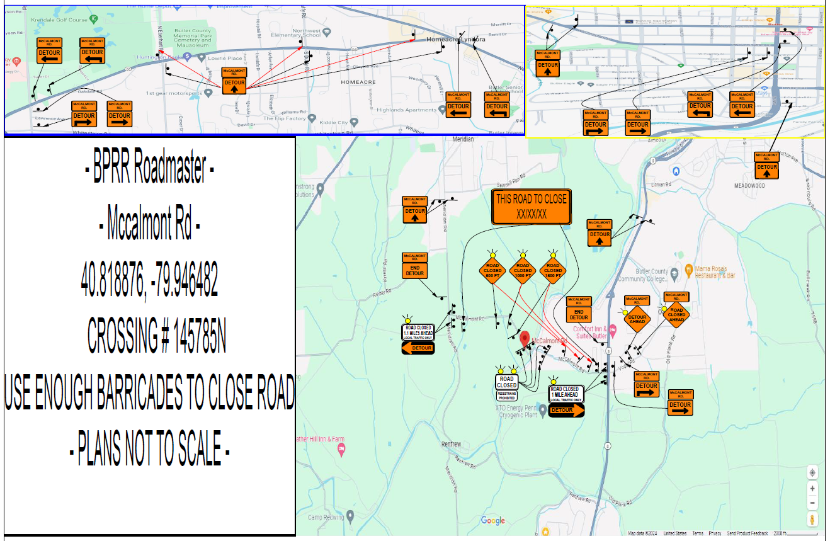

We trust this maintenance will be completed in a safe and timely manner with minor inconvenience.

Sincerely,
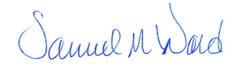
Samuel M. Ward
Chairman, Penn Township
Board of Supervisors

