May 14, 2024

Penn Township Residents,

**RE: Renfrew Street Closure - Railroad Announcement**

Good morning,

The Buffalo and Pittsburgh Railroad Company has announced the closure of Main Street Extension and Railroad Street this week for rail line and crossing maintenance. The announcement did not include the Meridian Road and Railroad Street intersection.

Residents North of the railroad tracks will have access to Meridian Road from Railroad Street.

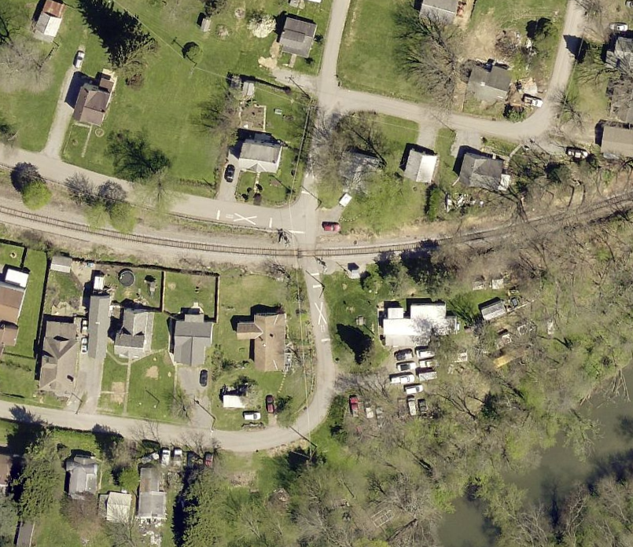

We trust this temporary inconvenience will lead to a permanent improvement.

Sincerely,

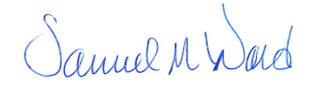

Samuel M. Ward

Chairman, Penn Township

Board of Supervisors